# **Department of Computer Science and Engineering Islamic University of Technology (IUT)** A subsidiary organ of OIC

# **Laboratory Report**

# CSE 4412: Data Communication and Networking Lab

## 

|  |  |
| --- | --- |
| **Name** | **: M M Nazmul Hossain** |
| **Student ID** | **: 200042118** |
| **Section** | **: 1** |
| **Semester** | **: 4th** |
| **Academic Year** | **: 2021-2022** |
| **Date of Submission** | **: 16.01.2023** |
| **Lab No** | **: 1** |

### 

### **Title:** Introduction to different transmission media and crimping of RJ45 Connector to UTP cable

### **Objective**:

1. Introduction to different guided media such as UTP, Coaxial Cable, and Optical fiber.
2. Internal arrangement of UTP cables.
3. Different Wiring Pattern Standards such as T568A or T568B.
4. Different types of cabling for UTP such as straight through, crossover, rollover, and their usage.
5. Procedure to crimp RJ45 connector to UTP cable.
6. Procedure to check the connection.

### **Devices Used in the experiment:** Cat5e/Cat6 Ethernet Cable, RJ-45 Crimping Tool, RJ-45 Crimpable Connectors, Cable Tester.

### **Theory:**

Talking to someone over the telephone, their voice seems to change a lot. But as long as what they are saying is understandable, it’s not an issue. This change happens because of data loss. In the age of the internet, if there was any data loss, while we were transferring data, it would render the data unusable. For this, we need cables with multiple high-quality wires. To solve that problem, different cables were introduced which serve the purpose at different speeds of connection. One of them is a Cat5e/ Cat6 ethernet cable which has a bandwidth of up to 1000 Mbps.

An Ethernet cable consists of 4 pairs of twisted wires, covered by an outer jacket. Each twisted pair of a white wire and a colored wire. The wires are made of solid copper conductors, covered by an out insulator. The white part of the cables are positive ends and the pure color parts are negative ends. The twisted pairs of wires send the same data with opposite electrical polarity, as a means of canceling out electrical noise, which is needed for reliability at high speed.

The ethernet cable may be shielded or unshielded. Unshielded Twisted Pair (UTP) cables were used for this lab. UTP cables have a max distance of 100 m, and the signals sent through them have to be repeated before that, otherwise, there might be data loss.

There are two major UTP cable standards used in the networking industry. Following the standard makes it easier to track how the cable works and will make it easier to repair it if something happens. The two standards are T568A and T568B.

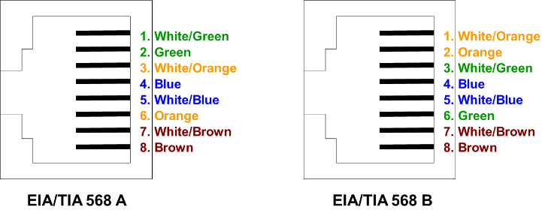

**Fig: The cable orientation standards**

Cable no. 1 and cable no. 2 are used for transmitting signals and Cable no. 3 and cable no.6 are used for receiving. The color-pair of wires used for transmitting and receiving is switched in T65A and T568B standards, keeping the blue and brown wires constant. However, these wires are “no connection” for low-speed connections. This means, even if these wires aren’t connected properly, the ethernet cable would still function properly as they are just there for future use, as a separate ethernet connection, or power transfer. However, all 4 pairs are needed for a high-speed connection of over a gigabit. For now, we are only working with 2 pairs.

Based on the types of devices which have to be connected, there are different standards of cabling.

Straight-through cabling, where at each end, the same orientation of T568A or T568B is followed. Straight-through cabling is used for connecting devices of different categories, like connecting a PC with a Switch.

Rollover cabling is used to connect a computer terminal to a router’s console port.

Crossover cabling is where at one end, T568A is followed and at another end, T568B is followed. Crossover cabling is used for connecting the devices under the same category, like connecting two PCs or two Switches. Modern computers can use straight through for two computers, but it’s still better to follow the standard.

### **Working Procedure:**

1. The cable is covered by a protective plastic jacket. The cable jacket has to be stripped using the crimping tool as much as needed (about 1.5-2 inches).
2. Inside there are 4 pairs of twisted cables twisted together. Untwist them and keep them separated.
3. Decide what type of cable to make and the standard of the orientation between T568A or T568B of the cable accordingly. A straight-through ethernet cable was made for this lab using the T568B orientation standard.
4. Untwist the twisted pairs and align them in the sequence of the oriented. In this case, since the standard being followed is T568B, the cables were arranged in the following order: White-Orange, Orange, White-Green, Blue, White-Blue, Green, White-Brown, and Brown.
5. The end of the arranged wires is cut using the crimping tool to straighten out the wires. The wires should be cut in such a way that, when the wire is placed inside the crimpable connector, the edge of the connector has a piece of the ethernet cable with the plastic shield around it, to make crimping possible.
6. The cable is inserted carefully inside the connector. Placing the connector clip side down, and the insertion point facing toward me, the left side of the connector is where the 1st cable should go.
7. The wires are pushed all the way inside the connector, making sure the edge of each cable reached the end of the connector.
8. The connector is placed inside the 8p port of the crimping tool and the crimper is squeezed all the way down.

### **Diagram of the experiment:**

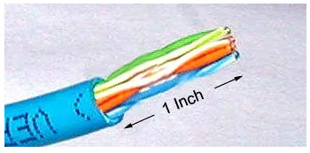

1.5 Inch

**Fig: Step-1**

[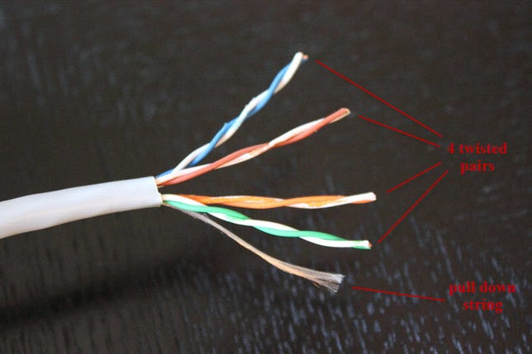](http://i.i.cbsi.com/cnwk.1d/i/tim/2011/08/03/4-twisted-pairs.jpg)

**Fig: Step-2**

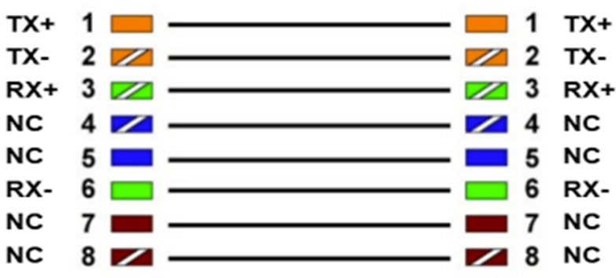

**Fig: Step-3**

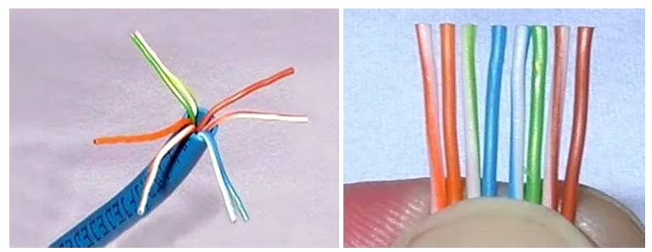

**Fig: Step-4**

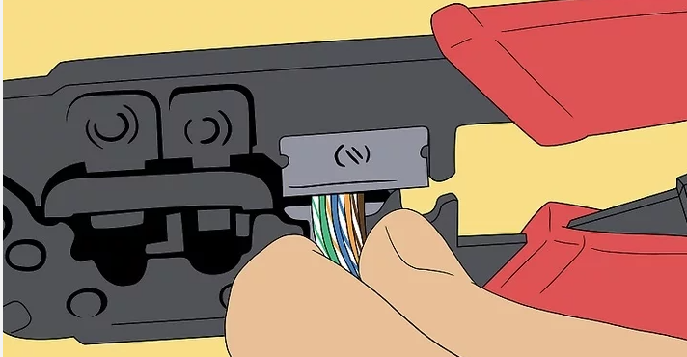

**Fig: Step-5**

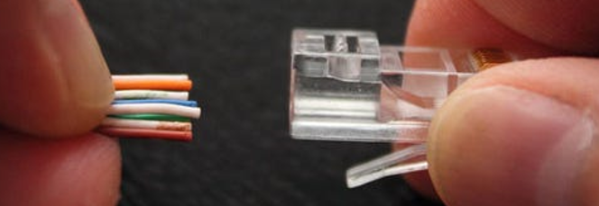

**Fig: Step-6**

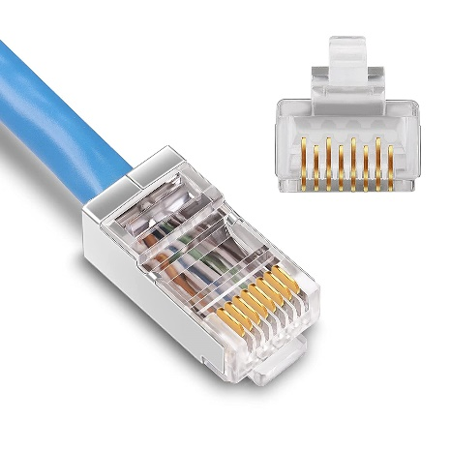

**Fig: Step-7**

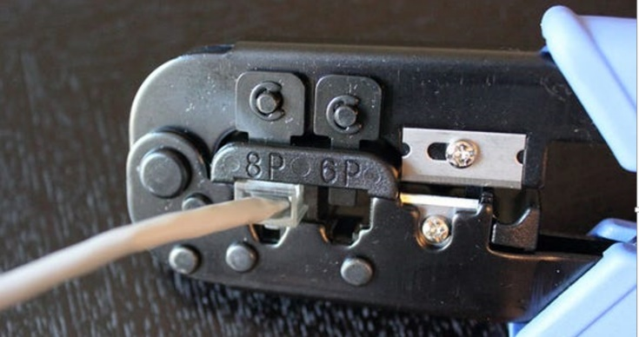

**Fig: Step-8**

### **Observation**:

### After preparing both ends of the cable alongside a classmate, the cable is submitted for testing. A cable tester is used to test the successful preparation of the cable. One end of the tester sends a signal and another end receives it. If all the signals match each other, then the cable was prepared successfully.

**In this lab, we were able to successfully prepare the cable.**

### **Challenges:**

The main challenge for this lab was grasping all the theoretical concepts. Since most of the topics covered were completely new to us, it was a bit difficult to understand all the concepts properly. Which end of the connector receives the first wire was a question that kept coming up again and again. The lack of sufficient crimping tools meant we had to scurry through the lab in search of a free crimping tool.

Overall, the lab was a positive experience and quite memorable.